*Project Assessment Documentation*

Rental House Finding System | FOO Team

Supervisor: Mr. Phan Truong Lam

Students: NamNV01595

HungCQ01766

BichTT01501

VietVH01388

ChungNT01726

I. IDEAS

Nowadays, in the big cities such as Hanoi and Ho Chi Minh have many job opportunities, good infrastructure, universities and living standard. Therefore, a large number of people and students come from other provinces to work and study. The need of finding a house for lease is definitely becoming very popular and necessary.

Normally, people spend lots of time for asking friends or try to go around and around to find a suitable flat.

Coming with the fast developing of communication technology, other people could also find house by surfing websites on the Internet. There is a lot of information on the Internet. However, there are still lots of unnecessary information, out of date information of rental rooms, flats, and houses. As a result, people must spend lots of time for searching suitable one.

Base on ideas of building web application for help people find their suitable rental house and creating the connection between house owners and renters. Our website will help people to find house for lease more easily and efficiently, the lords have a faster & better way to approach their potential renters.

Hopefully, our website will be a bridge of connecting between house owner and people who want to lease the house.

II. LITERATURE REVIEW OF EXISTING SYSTEMS

Currently, there are some popular systems with quite similar services in comparison to our system, both in Vietnam and worldwide such as: <http://www.xomtrosv.com>, <http://www.nhatroviet.com> & <https://www.padmapper.com>

**XomtroSV.com**: In overview, this website has supported users quite well with many general features of a standard advertisement website; however:

* + - Website does not have comparing between similar topics.
    - It does not have view history and save favorites function.
    - It supports Google map but with limitation function implemented on this.



**nhatroViet.com**:

* + - Each post has enough information: address, room type, date, rent, electric and water fees, contacts, etc.
    - Suggestion shows rooms on the same district.
    - Provide more related information that user may need:
      * News related to room seeking, giving user more information.
      * Can search for buses by number or by route.
    - No bookmark and rating
    - Google Map implementation has bug
    - Suggestion doesn’t show rooms on the same district, which helps users compare among candidate selections.

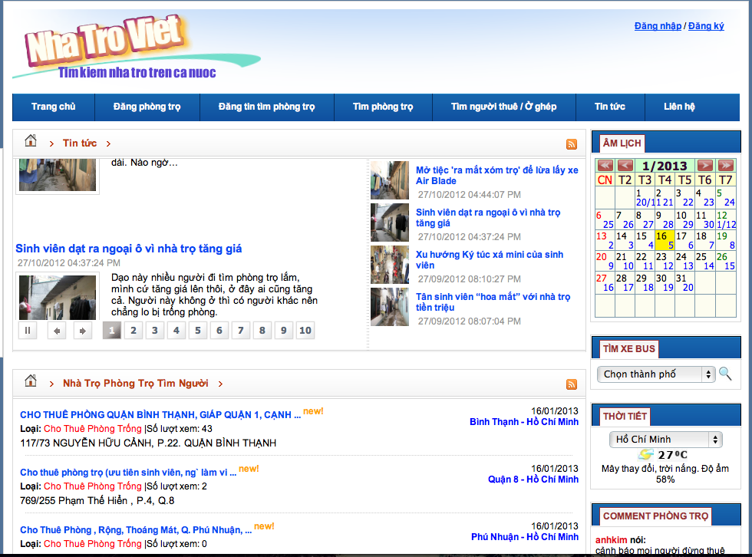

**Padmapper.com**:

* + - It has visual interaction:
      * Support of nearly full screen map.
      * Has markers on the map, which helps users identify the location better.
      * It has visual scrolls for users to set range of their search.
    - Favorite list for users to refer later.
    - No comparison function between 2 or more positions.
    - No suggestion for other places near selected positions such as universities, markets, and hospitals…

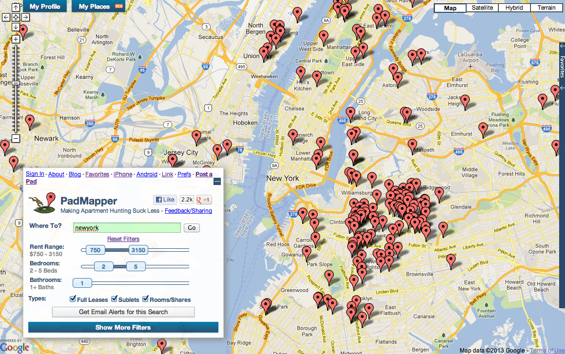

II. BASIC REQUIREMENTS & ANALYSISES

II.I. PROPOSAL:

Our website has a proposal brings better & faster way of searching, better user experiences. We focus on the following points:

* + Search function: should be faster, friendlier and more efficient with suggestion for users.
  + Visualization: Improve the interaction between users and visual maps in friendly & direct ways.
    - Results display as markers on the map. In low zoom level, results will be in-group, which have nearby location.
    - User can choose, view house detail information directly on the map.
  + Comparison: Help users review pros & cons of similar level houses before deciding to rent a house.
    - Help users compare basic information of each location.
    - Help users define the number, the distance of nearby social services such as: hospital, school, entertainment, government, (super) markets.

II.II. BASIC REQUIREMENTS

1. **Visitor Requirements**
   * + Visitor (non-registration user) can search, filter, rate, interact with visual map and view all results of houses in list view or map view.
     + Visitor can compare 2 or three information of houses before deciding to contact the house owners.
2. **Registered User Requirements**
   * + Registered users have all function of visitor above.
     + Users can edit their contact, private information.
     + Users can login to website by using Open ID (Google, Facebook, Yahoo).
     + Users can post, edit, delete new house for lease topic.
     + Users can renew their topic when their topic was expired (after 30 days).
     + Users can view, add, and delete many topics to their favorite list, which helps users refer later.
     + User can report a topic, which could be spam.
3. **Administrator Requirements**
   * + Admin has the full power in whole system.
     + Admin can view list of all users, user information, delete or ban users.
     + Admin can view list of post, add, edit and delete a topic.
     + Admin can view number of users & guest online each day.
     + Admin can check last activity of a specific user in system over 30 days.
     + Admin can view list of spam reported topics before deciding to delete them or not.
4. **System Requirements**
   * + System will hide the topic, which is not renewed after 30 days from the result list.
     + System will auto send mail to notify users about need renewed post.
     + System will show number of view, like and comment in each post.
     + System will show the number of user or visitor online at the same time.
     + System will save the last activity of users.
5. **Topic Requirements**
   * + Each post should have the following information: title, type, city, district, detail contact, price, area, water price, electric price, toilet motor parking, owner or brokers, internet, door closed time and image, location on map, view, rating and more description.
6. **Search Requirements**
   * + User can type any keywords on search textbox, system will auto suggest for user useful phase for keywords.
     + In result view list, the default order is based on a specific formula, which is related to number of view, rating, post date, like, comment.
     + User can use advance filter to narrow their search result.
     + User can also use advance search function, which have more restrict options.
7. **Visual Map Requirements**
   * + Visual map auto redirects to the location which user chose.
     + Auto shows all rental house in specific location above in group of nearby location in low level of zoom.
     + In detail level of zoom, when user clicks on a group, map will expand group and mark each location with one marker.
     + When clicking on a marker, map will show basic information of that location and open popup windows within map when user click “Chi tiết” button.
     + When user uses filter, search or advance search, the result will be changed the same with the markers on the map.
8. **Comparison Requirements**
   * + User can choose 2 or 3 locations (topic) in order to compare.
     + Showing the differences of basic information between above location for users.
     + Showing all social services near above locations such as: hospital, school, entertainment, government, (super) markets with the basic info and distance.